SWAG YOUTH NEWSLETTER
“Saved With Amazing Grace”
Celebrating Our Amazing Youth Achievements!
Scripture of the Month: John 14:2-3 (Verse 2) There is more than enough room in my Father’s home. If this were not so, would I have told you that I am going to prepare a place for you? (Verse 3) When everything is ready, I will come and get you, so that you will always be with me where I am. (selected by Roderick Daniels)

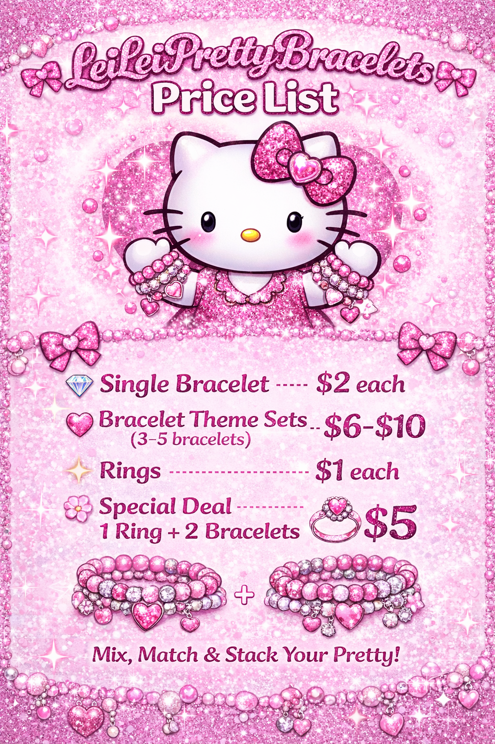
✨ Young Entrepreneur Spotlight – Leia Turner
Leia recently started her own business called “Lei Lei Pretty Bracelets.” Through her creativity, hard work, and determination, she is already showing what it means to be a young entrepreneur. Her bracelets are beautiful and made with care, and we are excited to see her continue to grow her business.
On top of that, Leia was also recognized as Student of the Month at school! This achievement reflects her dedication, positive attitude, and commitment to doing her best both in and out of the classroom.

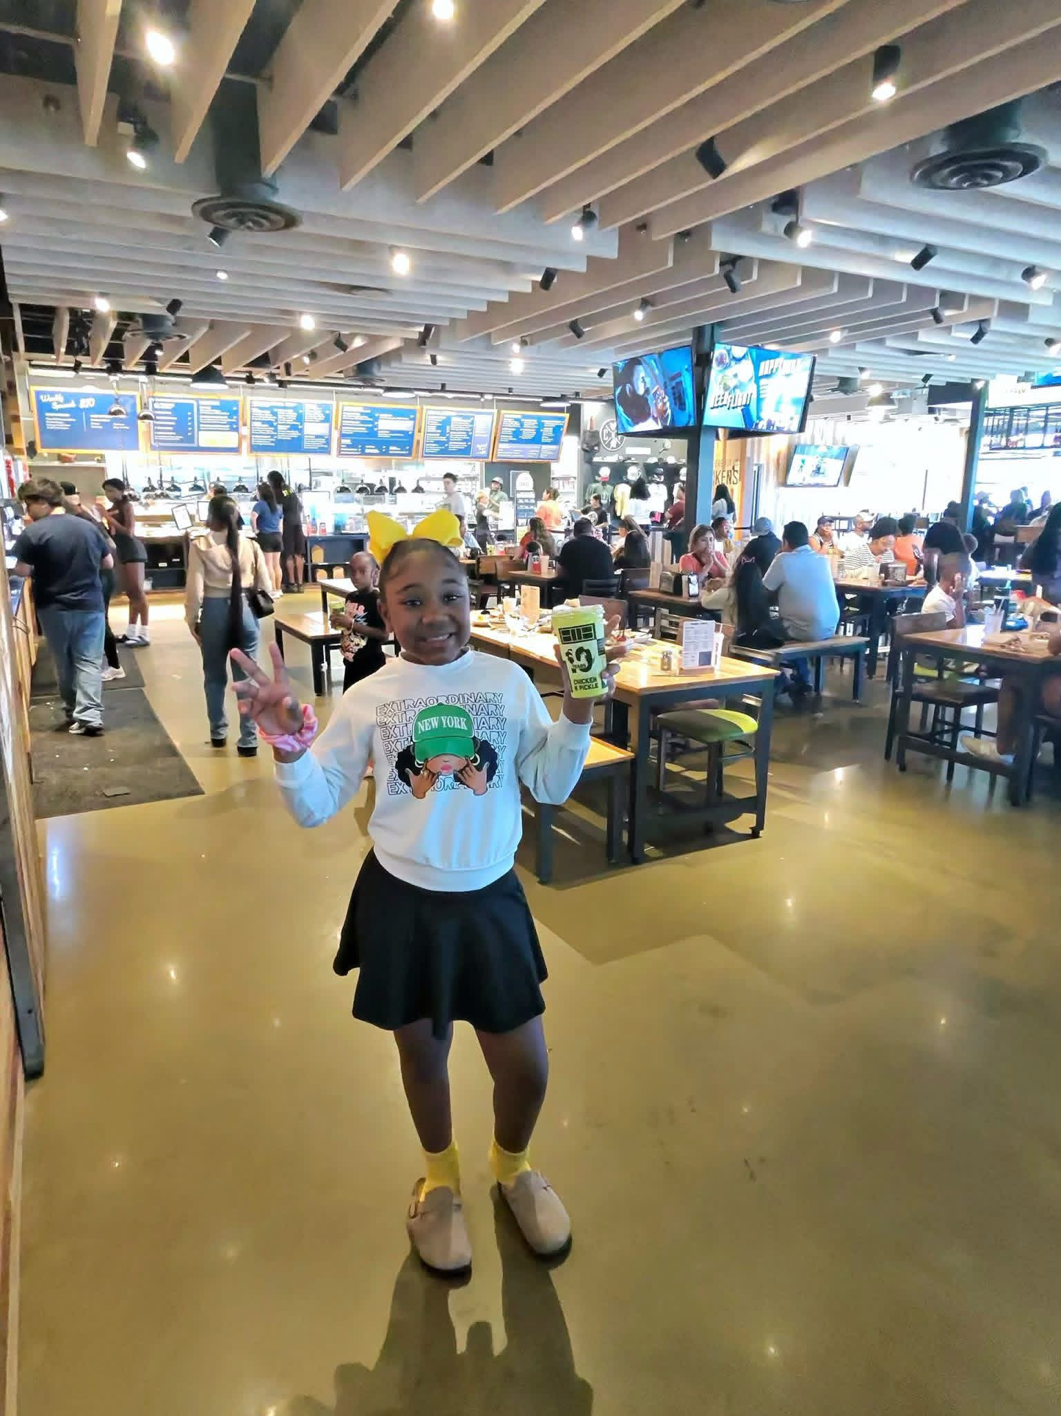
📚 Academic Achievement – Genesis Reese📚
We would like to proudly recognize Genesis for her outstanding accomplishments at school! Genesis recently received the Level Up Award for her improvement in both Math and Reading. Her progress shows that with effort and perseverance, great things can be achieved.
We are so proud of Genesis for continuing to push herself and strive for success. Please join us in congratulating her on this amazing achievement and encouraging her as she continues to grow and shine!

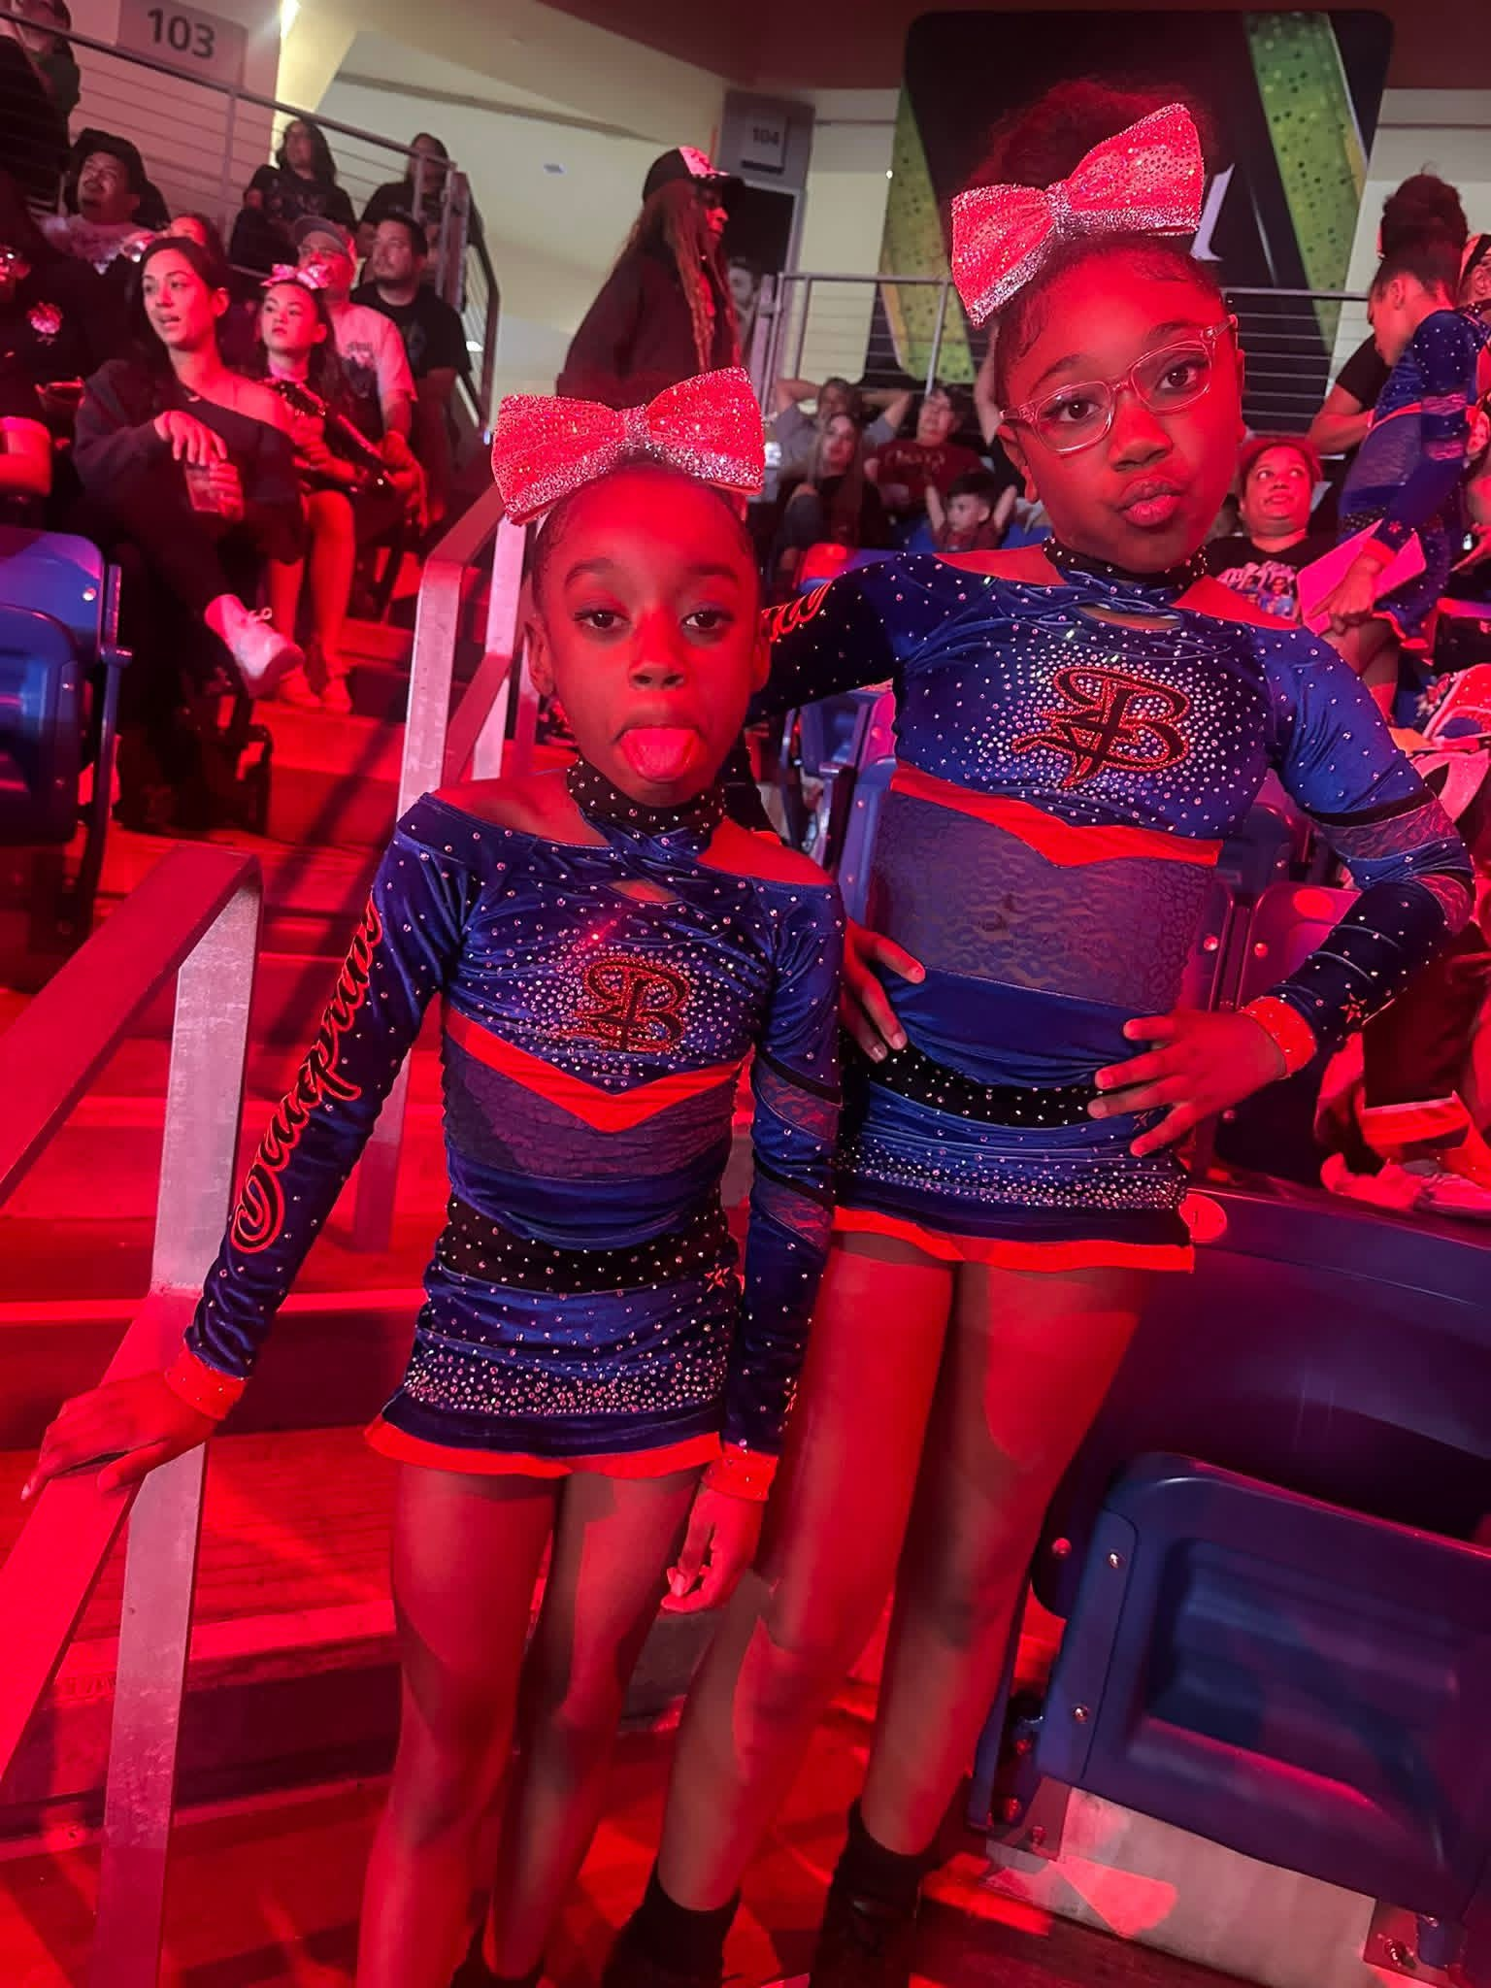
🏆 Cheer Champions – Genesis & Germany 🏆
What happens when talent, teamwork, and determination come together? A 1st Place victory!
A huge congratulations to Genesis and Germany for winning 1st Place at a cheer competition in Las Vegas. Competing on such a big stage takes confidence, and these young ladies showed exactly that.
Their accomplishment is not only something to celebrate, but also an inspiration to others to keep working hard and believing in themselves. We are proud to see our youth using their gifts and talents in such positive ways.

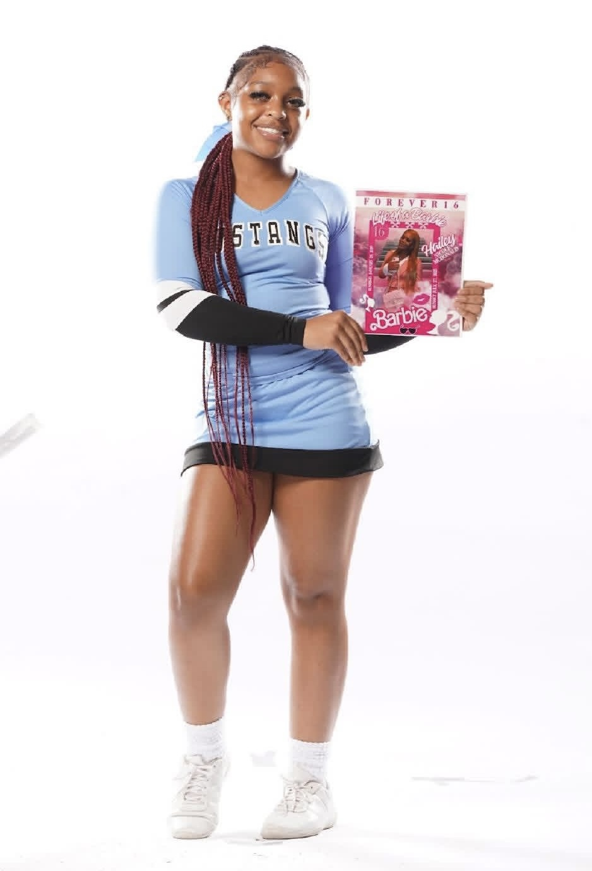
📣 Varsity Cheer Success – “Yaya” (Uniyah Williams) 📣
We are excited to celebrate Yaya for an amazing accomplishment!
Yaya recently made the Varsity Cheer Team for the upcoming school year. Earning a spot on varsity reflects her hard work, dedication, team spirit, and determination. Making varsity is a big accomplishment, and we are so proud of her for reaching this goal.

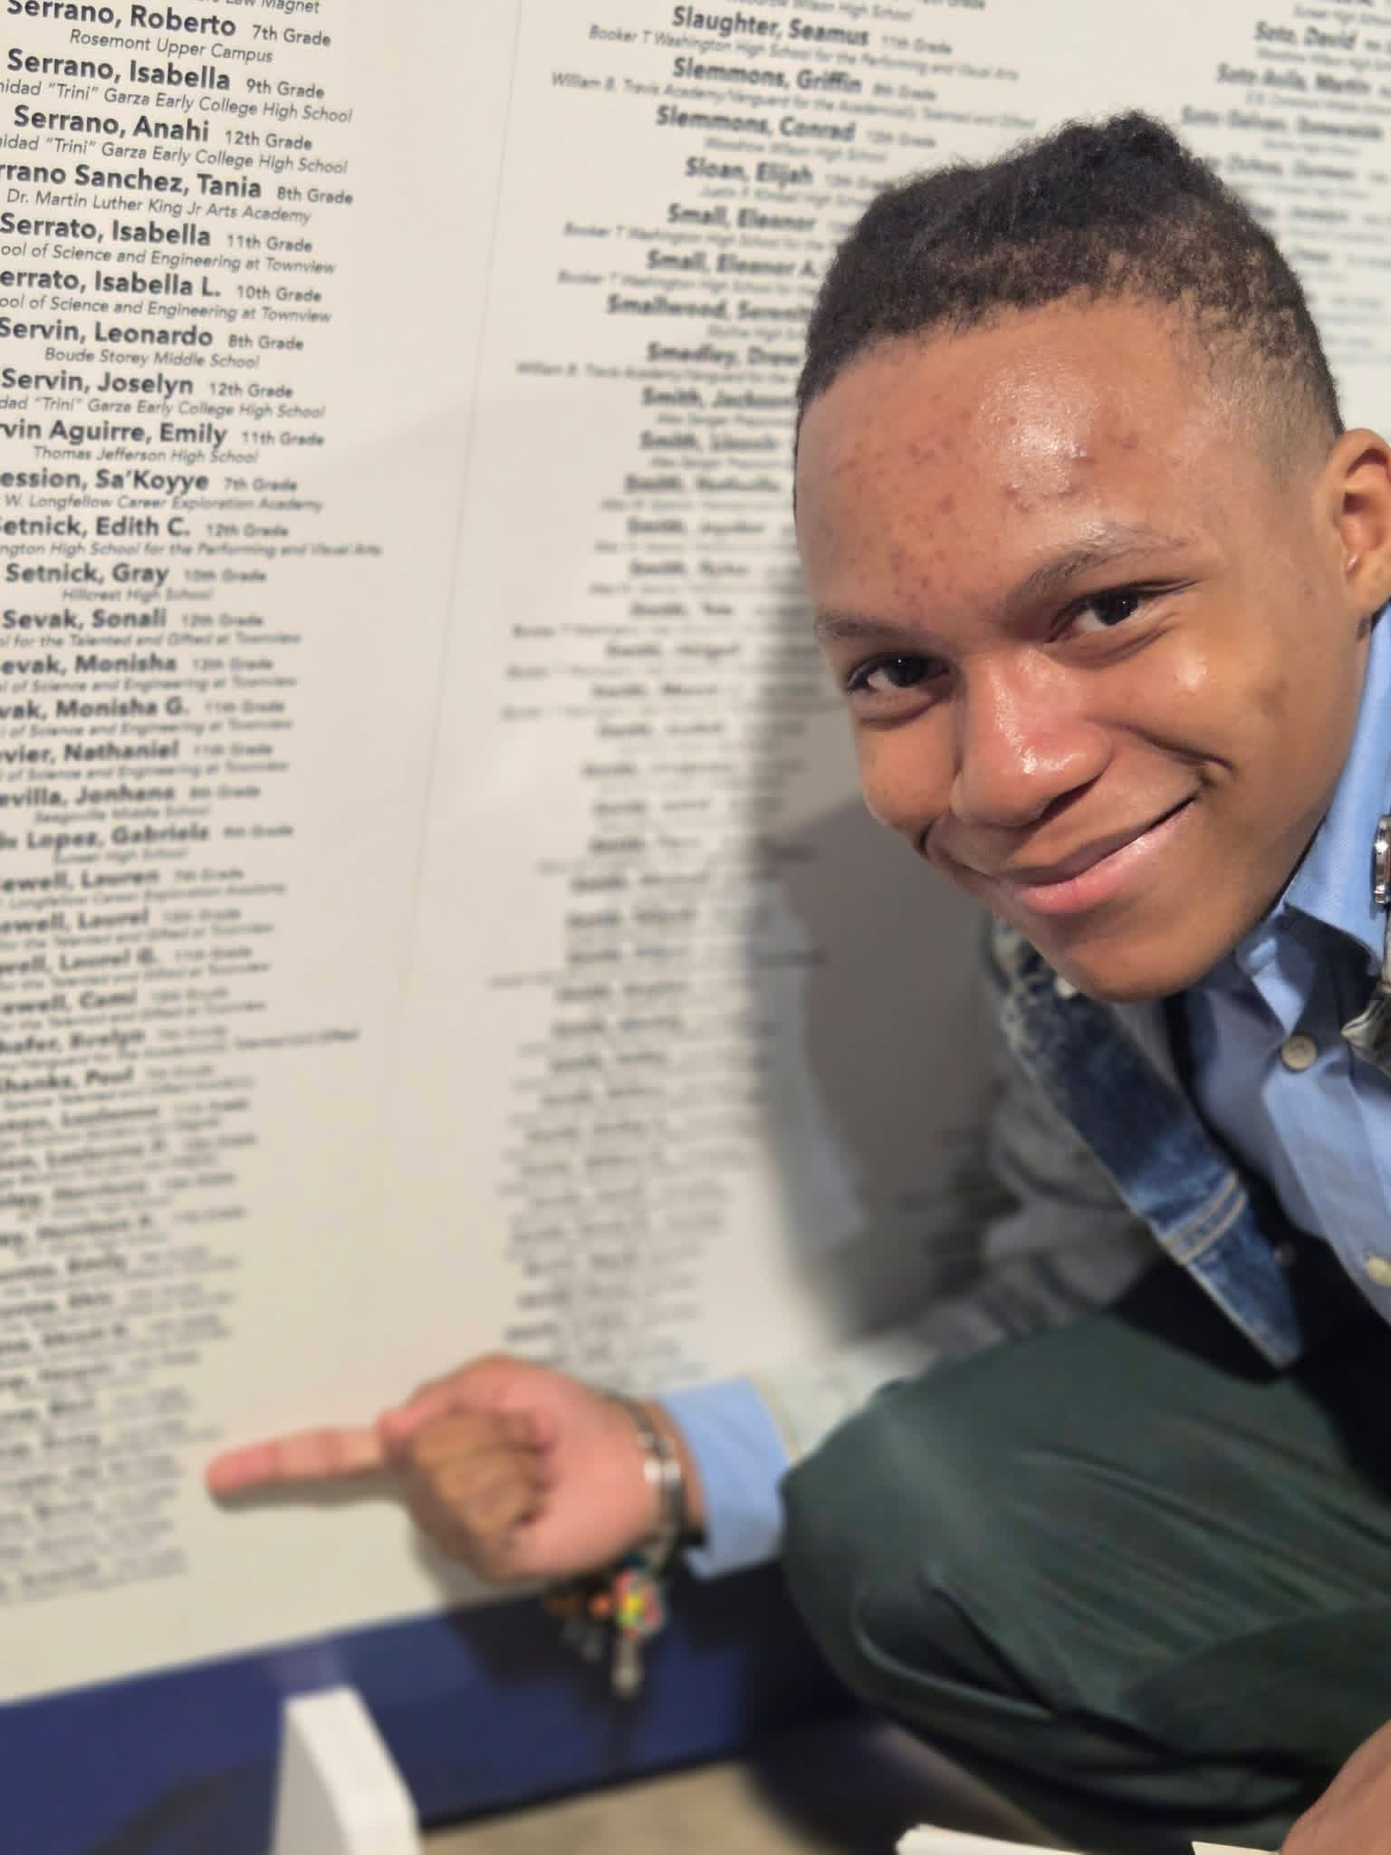
🎓 Academic Excellence – Jai Sharper 🎓
We are excited to share some wonderful news about Jai Sharper!
Jai has officially been accepted into Booker T. Washington High School, a great milestone that reflects his effort, focus, and commitment to his education. Being accepted into a school of this caliber is a big step forward and shows that his hard work is opening new doors for his future.
This achievement marks the beginning of an exciting new chapter, filled with opportunities to learn, grow, and continue striving for success. We are proud of Jai and look forward to seeing all that he will accomplish in this next season of his academic journey.

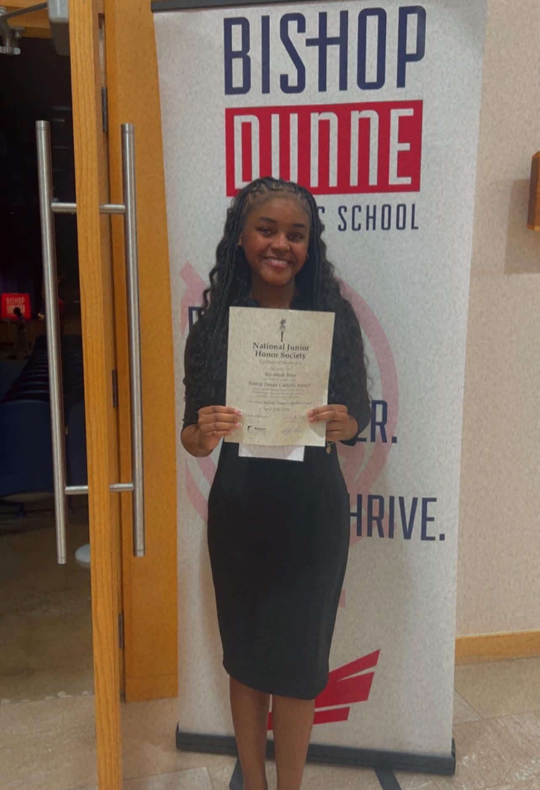
🌟 National Honor Society – Savannah Sims🌟
We are honored to recognize Savannah for a truly outstanding achievement!
Savannah has been officially inducted into the National Honor Society at Bishop Dunne Catholic School. This is a prestigious accomplishment that highlights her strong character, academic excellence, leadership, and commitment to serving others.
Her induction reflects countless hours of hard work, strong study habits, and a consistent commitment to doing her best in every area of school life. It also shows her willingness to lead by example and positively influence those around her.

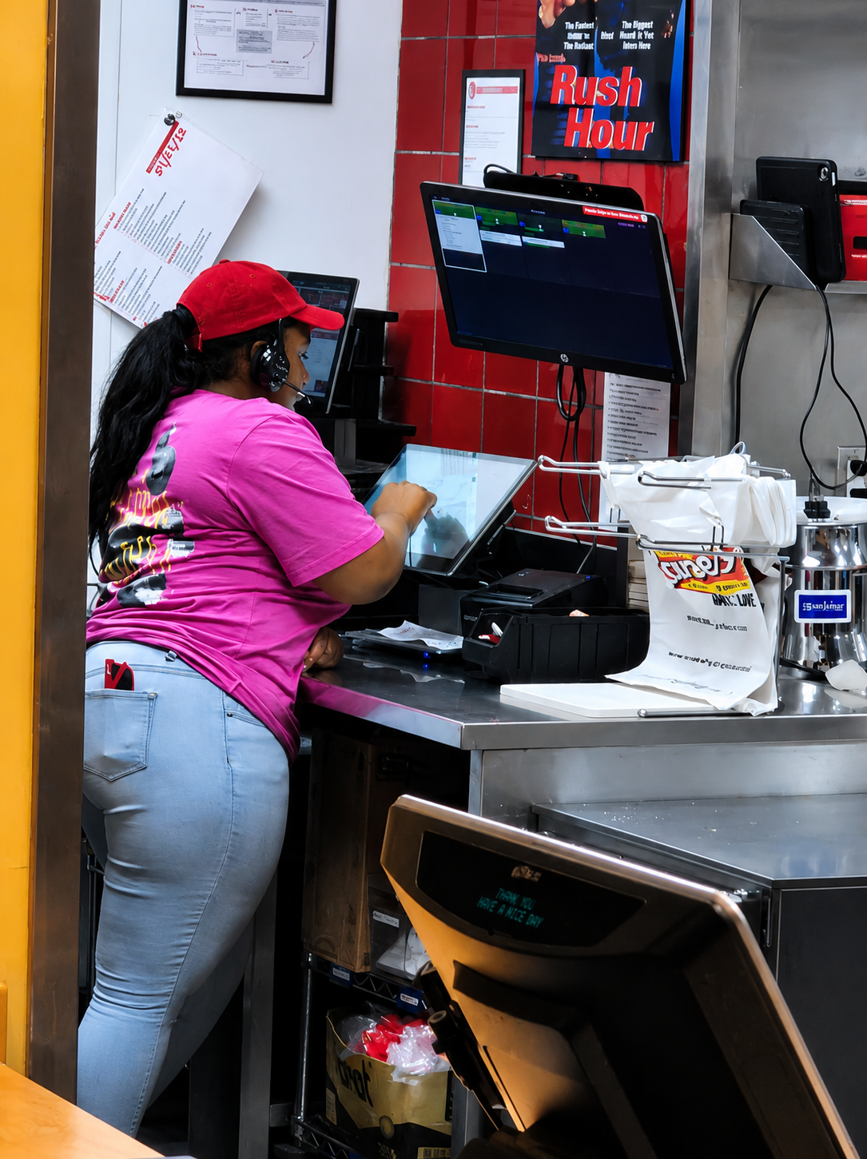
First Job Celebration – Saniah Green
Big congratulations to Saniah on starting her very first job at Raising Cane’s!
Saniah has officially entered the working world, and let’s just say… she’s about to learn that “extra sauce on the side” is not the only thing that comes with responsibility!
From learning new skills, working with a team, and staying on her feet, this is a big step forward and a great new experience for her.
We are all so proud of you, Saniah!

📅 Upcoming Events
✨ Vacation Bible School
July 14–17, 2026
5:30 PM Nightly
💡 Illumination Station
“Shining the Light on Who Jesus Really Is”
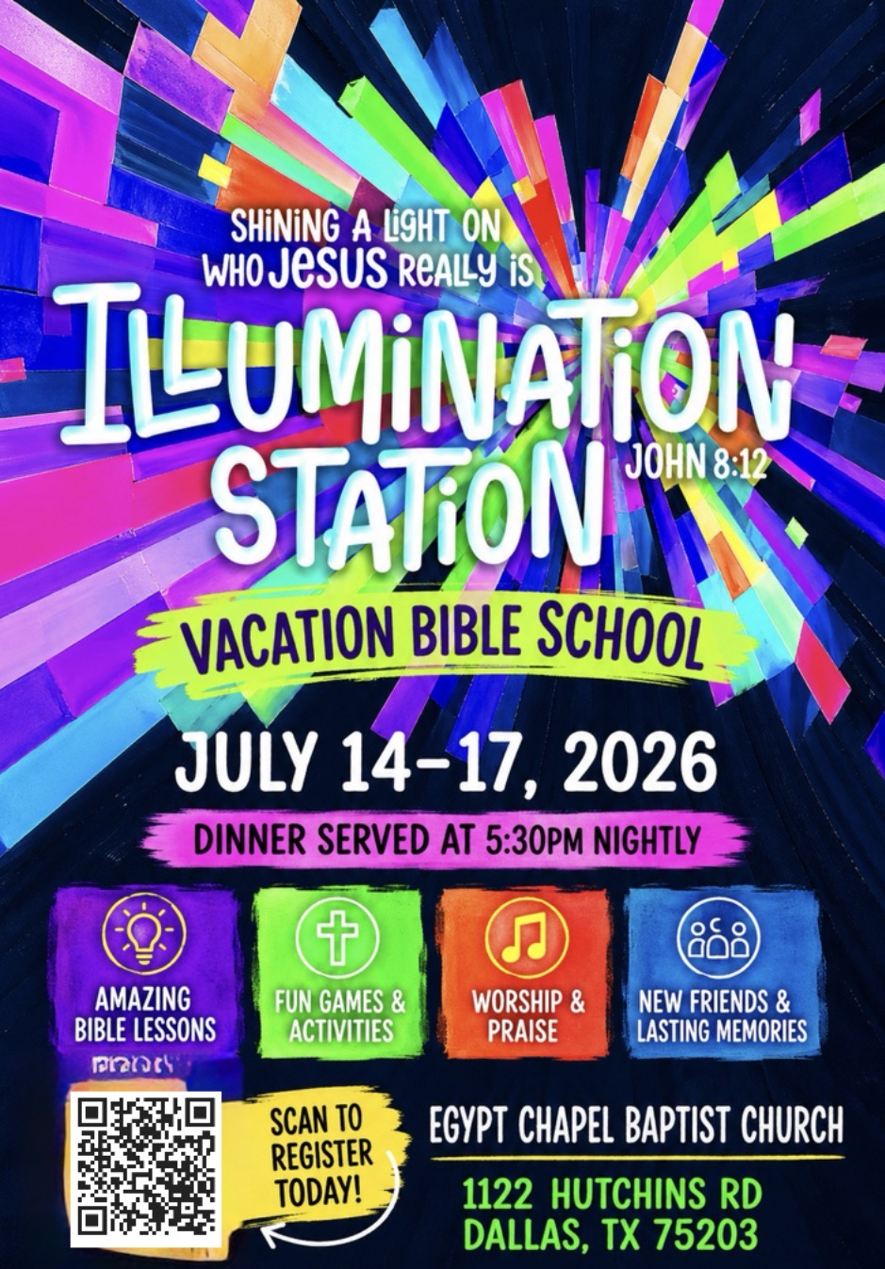

🎉 Youth EPIC Weekend – Annual Summer Trip
July 24–26, 2026
We can’t wait to see all of our youth join in for faith, fun, fellowship, and unforgettable memories this summer!
Cost: $200.00/per person
(Sponsorship opportunities available)
We’d love to celebrate all of our youth! Please continue to submit accomplishments, achievements, awards, school news, sports highlights, and special moments to Bria Smith or Minister Green so we can recognize and encourage our amazing young people. 💜✨
Keep shining, SWAG Youth! 💜
Newsletter Editor: Bria Smith

